Automatic Identify System (AIS)

Introduction

In combination with MaxSea, the AIS technology gives you an improved surveillance system and situation knowledge of ship traffic in the near area. | 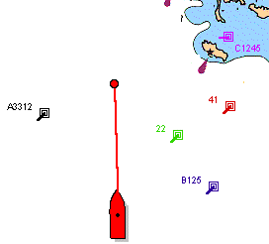

The three main components in the Trans-ponder are :
- GPS-receiver,
- VHF-transceiver,
- Computer.

The GPS-receiver provides accurate position and navigation data, the computer packs this information together and broadcasts the data on a digital data link via the VHF-transceiver. All ships within VHF range, equipped with an AIS transponder, can receive this message, unpack it and plot the position, vessel name (references), speed over ground, course over ground of the other ship on MaxSea. This means that every ship within VHF radio coverage may be automatically plotted.

Installation
After connecting the AIS System, you just need to configure the corresponding serial port at the
"AIS Transponder" Norm.
To do it go to the Data input output settings under the Utilities menu
Select the Radar tab and choose the line which

Display

MaxSea display information as target, such as ARPA target type radars. MaxSea displays the AIS targets on the chart and you can record the tracks, exactly as for your ship track .

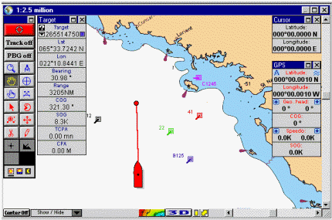
Note: each track point stores the date and the time, the position, as well as the speed and the heading of the target.

Target display

MaxSea displays automatically the icons for all the vessels tracked by the connected AIS system.

Using the Finger tool double click on a target to display the information window for this target, which shows the parameters received.
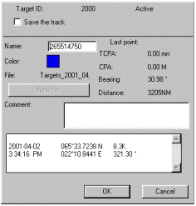

You can modify the name of the target and add a comment.

The Target tracking box is used to start and stop the display and recording of the target track , exactly as explained in your own ship.
Caution! The tracks of all the radar targets are recorded in the same file, created by default by the software but which you can modify .

Note: click New file to select a layer, other than the default one, on which you will record the track of all the targets.

Displaying the target palette
Select [Sensor Data] from the [Utilities] menu to display the target display, if the latter was not already displayed.

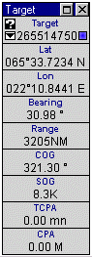 | Various information from target :  - Position,  - speed,  - heading,  - TCPA,  - etc…  are displayed and updated in real time.  The pop-up menu for the targets list, in the upper part of the display, is used to display information associated to different targets followed by the radar: click the pop-up menu to call it up and select the target for which you wish to display information.

Follow-up of mobiles

MaxSea follow up of mobiles : Operation

Once a request has been expressed, the information regarding the mobiles of the programme are operated by MaxSea® which displays and records all the positions of the various mobiles.

A mobile is defined by an identifier (generally a number, e.g. : 22445) and a name which is displayed on the map when the mobile is active (followed by the user). This name can be modified by the user.

Recording of new positions

When MaxSea receives the position of an unknown mobile, it creates a « mobile » object and displays it on the map, the name of such object then becomes the name of the mobile identifier.

When MaxSea receives the position of an already known mobile, it adds this new position to this mobile’s track .

The file may contain one or several positions of a mobile, all these positions being added to the mobile’s track.

Active/inactive mobile
An active mobile is a mobile which is actually followed up by MaxSea®. It is defined by means of an identifier and a name and its track is recorded

Active mobiles remain as such as long as the user does not request for this follow up to stop.

In order to stop the follow up of a mobile, double click on the mobile with the Finger tool then click on the button ‘Stop follow up’.
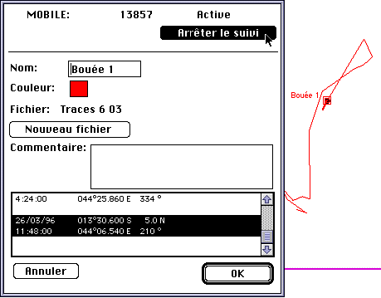

The track of the mobile now made inactive is then recorded in the file.

The name of the mobile also disappears from the list of followed mobiles (this list appears in the configuration dialogue of the request).

The tracks of all mobiles are recorded into one single file, the name of which appears in the track information window (see above).

Via Argos

ARGOS

By means of a modem and a communication software, the user has access to a server which supplies him with all the latest positions of mobiles to be followed.

This communication utility then records a file containing the positions. MaxSea® detects the presence of such file and has all the mobiles positions appear on the map.

Installation of the ARGOS module

Caution
We assume that MaxSea is properly installed on your hard disk. If not, please refer to the MaxSea installation manual.

It is absolutely necessary to install the module by means of the installation floppy disk - "PosReport Installer"
supplied by I&M or from the CD Inter, Tools/ MaxSea Utilities/ PosReport Installer "Pour PC".

In order to do so, insert this floppy disk and double click upon the icon named "Installation".

Records and files

The installer will create an "ARGOS" record and will order the necessary files when using the Argos module.

The "ARGOS " record is placed in the MaxSea record located in the system record and includes the "ARGOS_ACCESS" file, that is an automaton managing the communication with the ARGOS server in Toulouse as well as all the configuration files of the Argos module.

Configuring the communication on PC
You may experience some troubles to establish the communication with the coast
earth station (CES).
So you can adjust some parameters by overwriting the "Com Parameters ARGOS.txt"
file, which is located in the "C:\Windows\Maxsea\ARGOS" directory.

The different parameters are the following:

Modem communication port :
ComPort = n
where n is the serial port on which the modem is connected.
Modem initialization string

InitString = ATxxx
where xxx is the initialization command (for example, use ATZ in most normal
cases, or AT&Q5 to enable MNP error-control)

Dialing prefix
DialPrefix = ATDx
where x is T for tone dialing, or P for pulse dialing

Phone number
PhoneNumber = n
PSTN access : n = CES server phone number (33(0)561813625 for Aussaguel,
France Telecom)
X25 access : n = X25 PSTN gateway phone number (33(0)836064444 for Transpac,
France Telecom))

Server number
ServerNumber = n
PSTN access : leave this field "n" empty
X25 access : n = X25 server number (131021232 for Aussaguel, France Telecom
X25 server)

Activating ARGOS

Select [Argos Position Report] from the [Utilities] menu of MaxSea®.

Following the activation of this menu, a dialogue appears which enables on the one hand the configuration of the request you want to make to the Argos server and on the other hand to launch such request.

Configuring the access to the server

Prior to any request, it is necessary to enter the name of your programme, your user name and your password.

These personal data, which are available with the Argos company, will enable you to have access to the Argos server which delivers the messages from your mobiles.
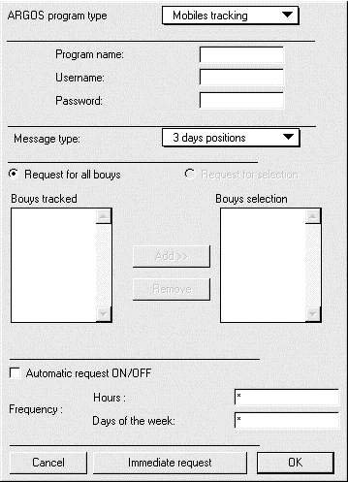

Configuring the type of message

Two types of message are available with the server :
- request about the latest positions of the mobiles (the server issues the latest known position of the mobiles only).
- ‘historical’ request issuing all known positions of the mobiles over the last one, two, three or four days.
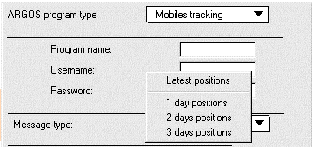

Configuring the type of request

Two types of request are available with the server :
- request about all the mobiles of the programme
- request for a selection of mobiles within the programme

For the first type of request, the server is asked for the positions of all the mobiles of the programme.

For the second type of request, the server is asked for the positions of the selected mobiles only.

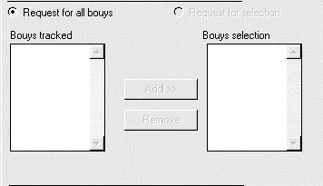

Launching the request

A request can be launched in 2 different ways :

- either manually, after having configured the request, by clicking upon the button « Immediate request ».

- or automatically, after validation by ticking the « ON/OFF Automatic Request » box, and selection of the requests frequency.

When the request is properly expressed, the communication software automatically quits, and MaxSea records the newly acquired positions of mobiles.

Configuring the frequency of automatic request

An automatic request is launched once the time and date set by the user are reached.

In order to set the frequency of connections, the user should enter his/her preferences regarding the time and days for calls in the 2 boxes provided to this end :

Time

The possible options are the following :
- ‘*’ if the user wants a request to be launched every hour
- from 0 to 23, i.e. number fixing the time of the request
- series of numbers separated by commas fixing the times of requests (for example: 3,6, 18 => requests at 3 a.m., 6 a.m. and 6 p.m.)

Week days

The possible options are the following :
- ‘*’ if the user wants to launch a request every day
- from 1 to 7, i.e. number fixing the day of the request (Monday = 1, Tuesday = 2....)
- series of numbers separated by commas fixing the days of request
(for example: 1,5 => requests on Mondays and Fridays each week)

Example:
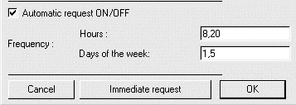

Automatic requests are asked for every Monday and Friday each week à 8 a.m. and 8 p.m.

Via Standard C

Standard-C

By means of a modem and a communication software, the user has access to a server which supplies him with all the latest positions of mobiles to be followed.

This communication utility then records a file containing the positions. MaxSea detects the presence of such file and has all the mobiles positions appear on the map.

Installation of the Standard-C module
Caution

We assume that MaxSea is properly installed on your hard disk. If not, please refer to the MaxSea installation manual.

It is absolutely necessary to install the module by means of the installation floppy disk - "PosReport Installer" supplied by I&M or from the CD Inter, Tools/ MaxSea Utilities/ PosReport Installer "Pour PC" .

In order to do so, insert this floppy disk and double click upon the icon named "Installation".

Records and files

The installer will create an "STDC" record and will order the necessary files when using the Standard-C module.

The "STDC " record is placed in the MaxSea record located in the system record and includes the "STDC_ACCESS" file, that is an automaton managing the communication with the STANDARD-C server in Toulouse as well as all the configuration files of the Standard-C module.

On PC, a communication software is installed in the MaxSea record.

Configuring the communication on PC (STDC)
You may experience some troubles to establish the communication with the coast
earth station (CES).
So you can adjust some parameters by overwriting the "Com Parameters STDC.txt"
file, which is located in the "C:\Windows\Maxsea\STDC" directory.

The different parameters are the following :

Modem communication port :
ComPort = n
where n is the serial port on which the modem is connected.
Modem initialization string

InitString = ATxxx
where xxx is the initialization command (for example, use ATZ in most normal
cases, or AT&Q5 to enable MNP error-control)
Dialing

